Assignment 3
1. Navigate to https://souravganguly.co.in/records-accolades/
2. Write Xpath for below :
- To get the runs scored in ODI using parent and starts-with text ‘Runs’

- //td[text()='Runs scored']/parent::tr/child::td[@class=' column-odi']

- //th[text()='Runs']/ancestor::div//child::th[text()='ODI']/ancestor::thead/following-sibling::tbody/child::tr/td[text()='Runs scored']/following-sibling::td[@class=' column-odi']

- Batting average in first class Cricket using following sibling and text ‘Batting average’

- //tr/child::th[@class='wdtheader sort sorting_disabled column-fc']/ancestor::thead/following-sibling::tbody/child::tr/td[text()='Batting average']/following-sibling::td[@class=' column-fc']

- Wickets taken in ODI using preceding sibling and text ‘Wickets’

- //th[text()='ODI']/preceding-sibling::th[text()='Competition']/ancestor::thead/following-sibling::tbody//child::td[text()='Wickets']/following-sibling::td[@class=' column-odi']

- Matches lost at Away from 2000-2005 using text ‘At Away’ and year(span) 2000-2005

- //table[@id='table_5']//th[text()='Lost']/ancestor::thead/following-sibling::tbody//child::td[text()='At Away']/following-sibling::td/following-sibling::td

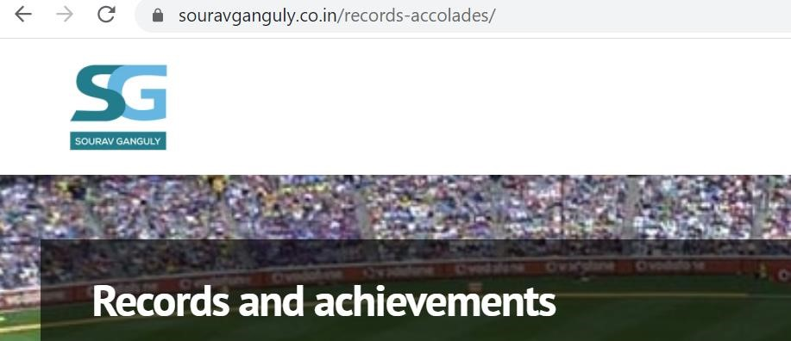
3.

X
path for the text
-

Records and achievements

- //span[text()='Records and achievements']

